**Пайдалы сілтемелер**

BilimLand     <https://bilimland.kz/kk>

[](https://182kazaly.edu.kz/images/it11/2/1.png)

Kundelik   [https://schools.kundelik.kz](https://schools.kundelik.kz/)

[](https://182kazaly.edu.kz/images/it11/2/2.jpg)

Opiq.kz    [www.opiq.kz](http://www.opiq.kz/)

[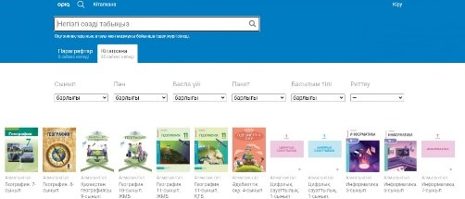](https://182kazaly.edu.kz/images/it11/2/3.jpg)

Daryn.kz    [https://daryn.kz](https://daryn.kz/)

[](https://182kazaly.edu.kz/images/it11/2/4.jpg)

Мектеп формасы

[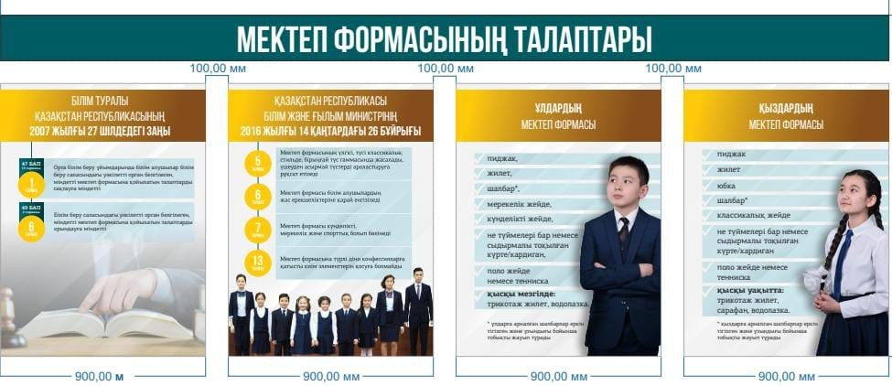](https://182kazaly.edu.kz/images/it11/2/5.jpg)